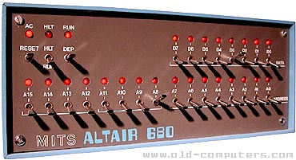**Release : software27.zip**

Having given it a bit of thought, I think I will write the interpreter for VTL-2 instead.

MINOL is quite interesting, and a fair chunk of the interpreter is actually written, but I think its limitations – which are primarily the 1 byte arithmetic options, are just a bit limited. The advantage it does have – the sort of string handling – I don’t need for Star Trek.

On the upside, code is usually better when restarted – I did write some part of the VTL-2 interpreter originally , and it means I don’t lose my thoroughly tested 16 bit arithmetic routines that are in the monitor ROM.

I’ve moved the minol code and the minol expression tester to the miscellany directory in the software part of the release, so anyone who wants to can have a look at it.